# 

# Experiment No:5

**Aim: To implement menu driven programs for Link List, Stack and Queue in python Theory:**

A linked list is a sequential collection of data elements, which are connected together via links. A linked list consists of independent nodes containing any type of data and each node holds a reference or a link to the next node in the list.

The beginning node of a linked list is called the **head** and the end node is called the **tail.** All nodes of a linked list are independent and are not stored contagiously in memory.

# Types of Linked Lists

There are 4 types of linked lists that can be created in python. Singly Linked List

Circular Singly Linked List Doubly Linked List

Circular Doubly Linked List

# Stack:

In python, the stack is an abstract data structure that stores elements linearly. The items in a stack follow the Last-In/First-Out (LIFO) order. This means that the last element to be inserted in a stack will be the first one to be removed.

# Stack Operations

Various operations can be performed on a stack in python. Create Stack

Push



Pop Peek isEmpty isFull

deleteStack

# Queue

In python, the queue is an abstract data structure that stores elements linearly. The items in a queue follow the First-In/First-Out (FIFO) order. This means that the first element to be inserted in a queue will be the first one to be removed.

# Queue Operations

Various operations can be performed on a queue in python. Create Queue .

Enqueue Dequeue Peek isEmpty isFull deleteQueue



# PROGRAM

**Program 5.1: Stack**

**# Program introduction statement**

class Student:

    def __init__(self, name, roll_number, grade):

        self.name = name

        self.roll_number = roll_number

        self.grade = grade

class StudentStack:

    def __init__(self):

        self.stack = []

    def push(self, student):

        self.stack.append(student)

    def pop(self):

        if not self.is_empty():

            return self.stack.pop()

        else:

            return None

    def is_empty(self):

        return len(self.stack) == 0

    def display_details(self):

        if not self.is_empty():

            print("Student Details:")

            for student in reversed(self.stack):

                print(f"Name: {student.name}, Roll Number: {student.roll_number}, Grade: {student.grade}")

        else:

            print("Stack is empty.")

def main():

    student_stack = StudentStack()

    while True:

        print("\n1. Insert Student Details")

        print("2. Delete Student Details")

        print("3. Display All Student Details")

        print("4. Exit")

        choice = int(input("Enter your choice: "))

        if choice == 1:



    name = input("Enter student name: ")

            roll_number = input("Enter roll number: ")

            grade = input("Enter grade: ")

            student = Student(name, roll_number, grade)

            student_stack.push(student)

            print("Student details inserted successfully.")

        elif choice == 2:

            deleted_student = student_stack.pop()

            if deleted_student:

                print("Deleted Student Details:")

                print(f"Name: {deleted_student.name}, Roll Number: {deleted_student.roll_number}, Grade: {deleted_student.grade}")

            else:

                print("Stack is empty. No student details to delete.")

        elif choice == 3:

            student_stack.display_details()

        elif choice == 4:

            print("Exiting program...")

            break

        else:

            print("Invalid choice. Please enter a valid option.")

if __name__ == "__main__":

    main()

# OUTPUT:

# 



# Program 5.2:Queue

# Import Python Package

from queue import Queue

# Program introduction statement

print("Simple QUEUE Data Structure Program")

# Initial empty QUEUE

queue = Queue()

# Display Menu with Choices

while True:

print("\nSELECT APPROPRIATE CHOICE")

print("1. PUT Element into the Queue")

print("2. GET Element from the Queue")

print("3. Display Elements of the Queue")

print("4. Exit")

# Taking input from the user regarding choice

choice = int(input("Enter the Choice:"))

# USER enter option 1 then PUT elements into the QUEUE

if choice == 1:

# put() function to PUT elements into the QUEUE

queue.put("Monday") # PUT element Monday

queue.put("Tuesday") # PUT element Tuesday

queue.put("Wednesday") # PUT element Wednesday

queue.put("Thursday") # PUT element Thursday

queue.put("Friday") # PUT element Friday

queue.put("Saturday") # PUT element Saturday

queue.put("Sunday") # PUT element Sunday

queue.put('8') # PUT element 8

print('\nTotal 8 elements PUT into the QUEUE')

# USER enter option 2 then GET one element from the QUEUE

elif choice == 2:

if queue.empty():

# Check whether QUEUE is Empty or not

print('The QUEUE is EMPTY No element to GET out')

else:

# get() function to GET element out from the QUEUE in FIFO order

print('\nElement GET out from the QUEUE is:')

print(queue.get()) # Display the element which is GET out from the QUEUE



# USER enter option 3 then display the QUEUE

elif choice == 3:

if queue.empty():

# Check whether QUEUE is Empty or not

print('The QUEUE is initially EMPTY') # Display this message if QUEUE is Empty

else:

print("The Size of the QUEUE is: ", queue.qsize()) # Compute the size of the QUEUE

print('\nQUEUE elements are as follows:')

print(list(queue.queue)) # Display all the QUEUE elements

# User enter option 4 then EXIT from the program

elif choice == 4:

break

# Shows ERROR message if the choice is not in between 1 to 4

else:

print("Oops! Incorrect Choice")

# OUTPUT:

# 

# 

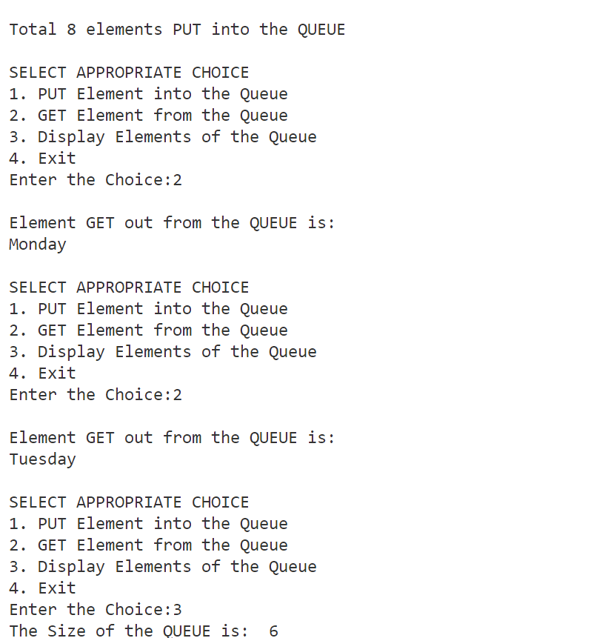

# Program 5.3:Linked List

class Node:

    def __init__(self, data):

        self.data = data

        self.next = None

class LinkedList:

    def __init__(self):

        self.head = None

    def append(self, data):

        new_node = Node(data)

        if not self.head:

            self.head = new_node

            return



last_node = self.head

        while last_node.next:

            last_node = last_node.next

        last_node.next = new_node

    def prepend(self, data):

        new_node = Node(data)

        new_node.next = self.head

        self.head = new_node

    def delete(self, data):

        if not self.head:

            return

        if self.head.data == data:

            self.head = self.head.next

            return

        current_node = self.head

        while current_node.next:

            if current_node.next.data == data:

                current_node.next = current_node.next.next

                return

            current_node = current_node.next

    def print_list(self):

        current_node = self.head

        while current_node:

            print(current_node.data, end=" -> ")

            current_node = current_node.next

        print("None")

# Example usage:

if __name__ == "__main__":

    linked_list = LinkedList()

    linked_list.append(1)

    linked_list.append(2)

    linked_list.append(3)

    linked_list.prepend(0)

    linked_list.print_list()

    linked_list.delete(2)

    linked_list.print_list()



# OUTPUT:

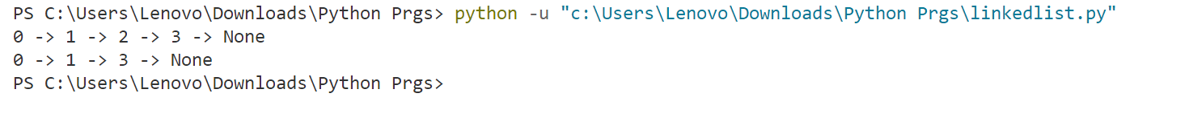

**Conclusion:**

The implementation of menu-driven programs for linked lists, stacks, and queues in Python has demonstrated their versatility and efficiency in managing data structures. Through this experiment, we have gained insights into the practical applications of these fundamental data structures, paving the way for further exploration and optimization in programming solutions.